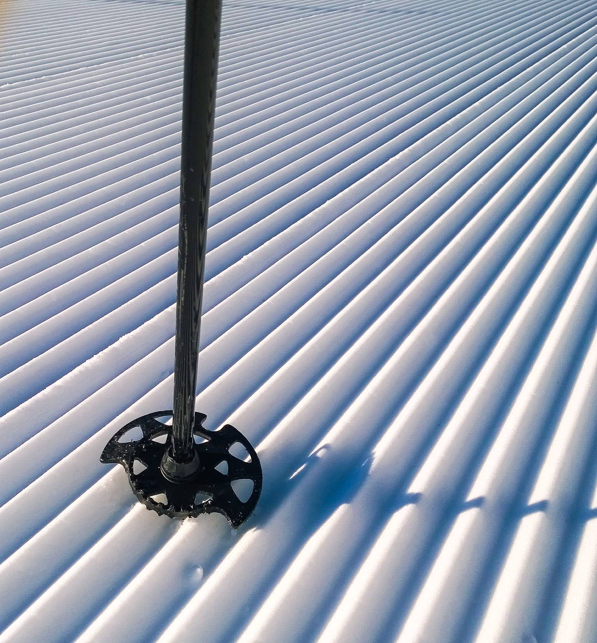
Have you taken a break or retired from patrolling? If you want to stay connected with NSP and were a patroller for at least one year (excluding candidate), you can become an alumni member.
Alumni membership is a way for former patrollers to remain affiliated with NSP. You can choose how involved you want to be, whether as an instructor or with your local patrol. You always have the option to go back to patrolling with current OEC and your patrol representative/director’s approval.
For only $35 a year, you’ll receive benefits including:
- Ski Patrol Magazine
- Discounts through the Online Store and
NSP Pro Deals Page
- Regular e-newsletters
- Ability to participate in NSP Training or Education programs
- Online access to the NSP website
- Voting rights in board elections

Become an alumni member today, and join over 5,000 other alumni who help support our great organization. Send in the form below with a check or money order for $35 made payable to:
National Ski Patrol
133 S. Van Gordon St., Suite 100
Lakewood, CO 80228
303.988.1111
alumni@nsp.org

Photo credit: Jan Nelson.
BECOME AN ALUMNI MEMBER TODAY!
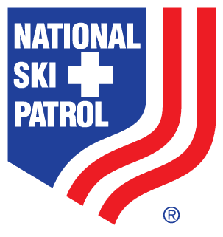
New Alumni Registration

Dues for 2022 - Membership paid through 12/31/2022 - $35.00
08/2021
Name |  |  |  |  | NSP Member #
Address |  |  |  |  | Phone
City |  | State |  |  | Zip
Email |  | Birth Date |  |  | Former Patrol

