PACIFIC NORTHWEST DIVISION
OUTDOOR EMERGENCY CARE

OEC Course Enrollment Fee
Payment Memo to PNW Division

Today’s Date: _________________ Name of Course: ____________________________
Course Type: ______________________________________________________________
Course Dates: _____________________________________________________________
Instructor of Record: ________________________________________________________
Instructor Phone #: _________________________________________________________
Instructor Email: ___________________________________________________________
Patrol: ______________________________ Region: ____________________________
# Students Enrolled * ______________ @ $10.00/ea. = $____________
* This is students enrolled not students who finished the course.
Student Outcomes (if known) : # Passed: ______ # Failed: ______ # Incomplete: ______
Note: Send this form with check made out to PNWD OEC FUND to the Division Treasurer for proper accounting.
PNWD Treasurer - Walt Seidel
5211 W Staley Rd.
Deer Park, WA 99006

The money collected from these fees enables the Division to provide an OEC Conference to its OEC IT’s and Instructors every other year.

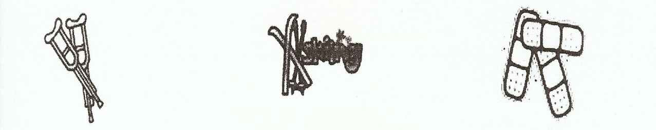

Rev 3-2024

